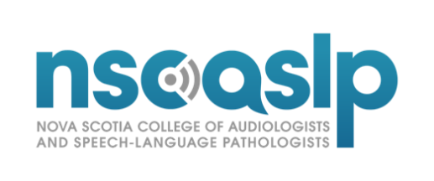
Request for Academic Documents

SECTION A: Instructions for Applicant
1) Please complete the top part of the form.
2) Submit this form to the institution’s Registrar, Controller of Examinations or other authorized school official.
First Name/ Given Name (s):
Middle Name(s):
Last Name(s)/ Surname(s):
Former Last Name(s):
Date of Birth:
Student ID Number:
I agree and allow my University, where I obtained my Audiology and/or Speech-Language Pathology education, to give the information asked for in the Request for Transcript and Clinical Hours to the Nova Scotia College of Audiologists and Speech-Language Pathologists (NSCASLP) so NSCASLP can complete my educational credential and qualifications assessment.
Date: DD/MM/YYYY | Signature:

SECTION B: Instructions for Institution
The student/graduate named above has applied to the Nova Scotia College of Audiologists and Speech-Language Pathologists (NSCASLP) for an educational credential and qualifications assessment. To help us complete the assessment, please provide the information asked for in the remainder of this document.
- Please complete the section B of this form. This form must be completed by a program official such as a Registrar, Program Director, Program Dean, or Principal.
The institution must email this form and a copy of the student/graduate’s official academic records (i.e., transcripts or statement of marks) directly to the NSCASLP. We will not accept documentation from the student/graduate. We will not accept this form if the applicant or any relative or friend of the applicant completes it or sends it to us.
Name of Institution/University:
Address of Institution:
Degree/Credential Obtained:
Graduation Date: | DD/MM/YYYY | School Seal/Stamp
Name of Official:
Title/Position
Phone Number:
E-mail Address:
Date: | DD/MM/YYYY
Signature:

